Project Title: Thermal-Aware Load Balancing Using Physics-Informed Neural Networks (PINN)
Project Domain: AIML, Computer Networks, Edge Computing, Distributed Systems, Green
Technology, Cyber-Physical Systems (CPS)
Name of the Company (for Industry Supported Project only): N/A
Name of the External Guide (for Industry Supported Project only): N/A
Inhouse Project: Yes

Abstract:
In the current age of high-density distributed computing, the performance of computational clusters is constrained by poor thermal management. This project proposes a new framework for Physics-Informed Thermal-Aware Load Balancing, an architecture built to balance high-performance execution with the thermal/heat limitations of processing nodes. By doing so, the health and reliability of the hardware are prioritized alongside performance and efficiency.
Traditional load balancing mechanisms are usually “thermal-blind”. Typical schedulers only optimize for performance based on metrics such as latency and throughput. Temperature issues are often handled once they arise either through throttling the processor or through using simple heuristics (if-else conditions) to reroute the traffic. As a result, when a processor is under heavy load and approaches its thermal limit, it will throttle its processing speed and cause a latency spike that propagates through the entire computing network. Current computing infrastructures generally lack a foresight into the effects of thermal behaviour and will only react to heat issues after the integrity of the hardware has already been compromised. Using a “Physics-Informed Neural Network (PINN)” approach to manage computing resources will replace reactive triggers with proactive actions to ensure hardware sustainability without sacrificing performance.
Software:
Category | Tools & Frameworks | Key Purpose
Machine Learning & Modelling | Python, PyTorch | PINN architecture and model training
Computation | NumPy, SciPy | Data generation and optimized model execution
Frontend/UI | Next.js, React, Three.js | Real-time system & thermal visualization
Backend API | FastAPI | Serving real-time load balancing decisions via REST
Testing & Quality Assurance | PyTest, FastAPI TestClient | Unit testing and API validation of requests/responses
Data & Storage | MongoDB Atlas | Persistence for logs and experiment results
Cloud & DevOps | Vercel, Hugging Face, Git | Full-stack deployment and version control

Hardware:
- Development and testing on standard personal computers
- Training on local GPU or Google Colab (CPU/GPU)
- No specialized hardware sensors are required

High-Level Design (HLD):
A cluster of processing nodes with limited cooling capacity, responsible for processing incoming computational workloads (tasks/jobs), not raw network packets.
1. Workload and Thermal Data Generator
- Generates workload arrival rates (tasks per second)
- Maps workload intensity to CPU utilization
- Simulates temperature evolution using simplified thermal equations
- Produces time-series data for workload, latency, and temperature
2. Physics-Informed Neural Network (PINN)
- Inputs: workload intensity, CPU utilization, ambient temperature, time step
- Outputs: predicted processing latency and node temperature
- Physics constraints enforced during training:
  - Temperature increases with increasing load
  - Temperature evolves smoothly over time (thermal inertia)
  - Latency increases with congestion
The PINN is trained once offline, validated, and frozen for inference.
3. Thermal-Aware Load Balancing Module
- Uses PINN predictions to evaluate load balancing decisions
- Assigns incoming workloads based on predicted latency and thermal scores
- Prevents workload assignment to nodes approaching thermal limits
- Enables comparison with traditional latency-only load balancing strategies
4. Visualization Dashboard and User Interface
- Interactive dashboard for non-technical users
- Displays node temperature, workload distribution, and load allocation decisions
- Abstracts all underlying physics and machine learning details

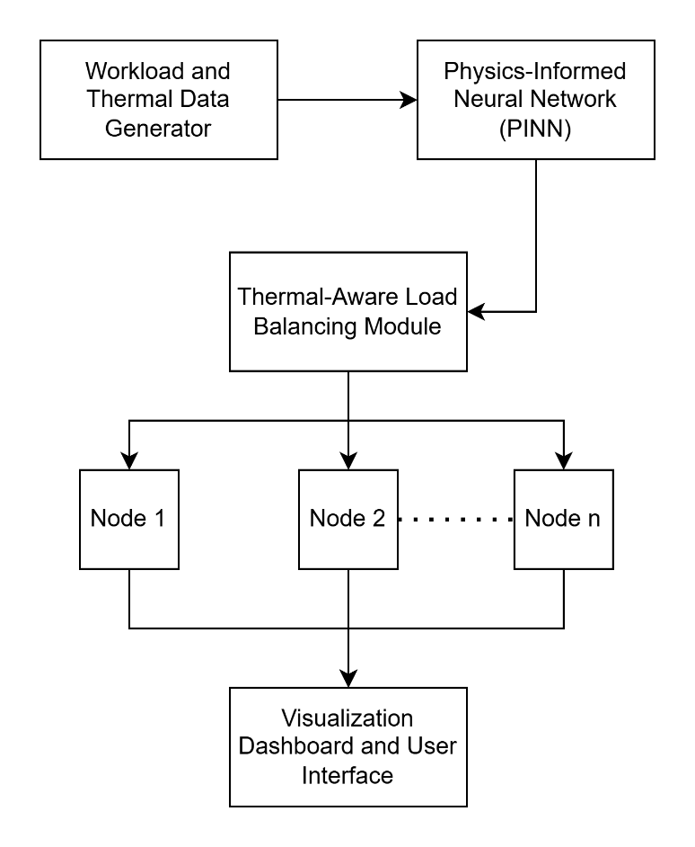
Block Diagram

Merging these two is not just possible—it is actually the "Final Boss" of project ideas. In the industry, this is called Cross-Layer Thermal and Traffic Management.
Instead of a hybrid that doesn't fit, you create a "Cyber-Physical Feedback Loop." ### The Concept: The Thermal-Aware Edge Router
In an Edge Computing scenario (like a 5G base station or an industrial gateway, the "Network Traffic" is what causes the "Thermal Heat."
- The Physics Link: More data packets processed per second $\rightarrow$ Higher CPU switching frequency $\rightarrow$ More power consumption $\rightarrow$ More heat generated.

The "Hybrid" Problem Statement
"Physics-Informed Emulator for Thermal-Aware Traffic Routing in Edge Computing Clusters."
The Pitch:
"In Edge Computing, nodes are often in harsh environments with limited cooling. Standard load balancers only look at network congestion, often pushing more data to a node that is already overheating, leading to hardware failure. My project uses a Multi-Physics PINN to simultaneously predict network flow and chip temperature. This allows the system to route traffic not just based on 'Who is fastest,' but on 'Who has the thermal headroom to process this data safely.'"

What the Project Looks Like (The "Hybrid" Architecture)
You would build a Unified PINN Engine that solves a coupled system of equations:
- The Traffic Part: Conservation of flow (ensuring data isn't lost).
- The Thermal Part: Heat conduction (predicting the temperature spike caused by that data).
The Final Deliverable (The "Wow" Factor)
Instead of two separate dashboards, you build one Integrated Command Center:
- The Map: A network graph where the nodes are 3D models of edge devices.
- The Interaction: As you "blast" a node with simulated network traffic (increasing the flow), the user sees the 3D model of that specific node turn from Green to Red in real-time.
- The Logic: Your system then automatically "reroutes" the traffic to a cooler node, and the user sees the first node's temperature drop.

Is it too complicated?
The Risk: The math gets harder because you are coupling two different types of physics (Fluid-like traffic + Thermal heat).
The CSE Solution: You don't have to solve them perfectly together. You can use two "heads" on the same Neural Network (a Multi-Task PINN).
- One head predicts Traffic Latency.
- One head predicts Component Temperature.
- They share the "System State" (CPU Load) as a common hidden layer.

Why this is the "Ultimate" B.Tech Project
- Unique Narrative: Most students do "Plant Disease Detection" or "Sentiment Analysis." Nobody does "Cross-layer Thermal-Traffic Optimization."
- Resume Gold: This covers AI, Networking, Computer Architecture, and Full-Stack Web Dev. 3. The "Industry" Angle: Industrial systems care about heat. A router in a factory floor is much more likely to overheat than one in a cooled data center. This project shows you understand the ruggedized nature of industrial tech.
Is it a "Hybrid that doesn't fit"?
No. In the real world, these two things are inextricably linked by the Second Law of Thermodynamics. Every bit of data processed eventually becomes heat. You are just the first person to use a Neural Network to model that relationship for a capstone project.

Free Tier Deployment Limitations
This is a very common "wall" students hit. Standard free tiers on Vercel or Render have strict memory limits (usually 512MB RAM) and short timeout windows, while a basic pip install torch alone can eat up over 700MB.
However, for a capstone project, the solution isn't to buy a bigger server—it’s to use a Decoupled Architecture. This is how professional engineers deploy heavy models for free.

1. The Strategy: Decoupled Inference
Instead of forcing your AIML model and your Web Server into the same tiny container, you split them up.
- The Frontend (Vercel/Render): Hosts your React/Next.js UI. It’s lightning-fast and stays within the free tier because it's just serving static files and making API calls.
- The Model API (Hugging Face Spaces): Hugging Face offers free hardware (CPU/T4 GPU) specifically for hosting ML models. You can wrap your PINN in a small Gradio or FastAPI app there. It provides a permanent URL that acts as your private "Inference API."

2. Model Optimization (The "Secret Sauce")
You don't need the entire DeepXDE or PyTorch library just to run the model (Inference). You only need them to train it.
- Convert to ONNX: Once your PINN is trained, export it to the ONNX (Open Neural Network Exchange) format.
- Why? An ONNX model file is just a few megabytes. You can then use the onnxruntime library, which is tiny compared to PyTorch. This is lightweight enough to run even on a Vercel Serverless Function or a GitHub Action.

3. The "Production-Ready" Tech Stack
To make this a "Hireable" project, here is the end-to-end stack:
Layer | Technology | Why?
Frontend | React / Next.js | Industry standard for full-stack apps.
Backend API | Node.js (Express) | Great for handling the "Hybrid" logic (Traffic + Thermal).
ML Engine | Python (FastAPI) | Hosted on Hugging Face Spaces for free persistent hosting.
Database | MongoDB Atlas | Free tier is perfect for storing "simulation logs."
Deployment | Vercel (Frontend) + Hugging Face (Model) | Zero-cost, high-performance combo.

4. What the Project Look Like End-to-End
- Training: You train your PINN locally (or on Google Colab) until the "Physics Loss" is near zero.
- Export: Save the weights as an onnx file.
- Deployment: * Upload the onnx file and a tiny FastAPI script to Hugging Face.
  - Deploy your Next.js app to Vercel.
- User Experience: * A user opens your website.
  - They move a "Workload Slider" for a CPU core.
  - The website sends a JSON request to your Hugging Face API.
  - The API returns the temperature map in 50ms.
  - The UI updates the 3D chip model instantly.

Why this is a "Top 1%" Project
Most students submit a local .ipynb file or a laggy local UI. By deploying a Decoupled System that actually works on a live URL, you prove you understand System Design, API Orchestration, and DevOps.

The REAL viability check (this matters most)
Answer this honestly:
“If the neural network fails, do we still have a working system?”
If yes → project survives.
And in your case:
- You can fall back to analytical models
- You can compare learned vs rule-based routing
- You can still demonstrate thermal-aware control
That’s the hallmark of a viable project.

Realistic timeline
Month 1 – Foundations
- Literature scan (1 week)
- Synthetic data generator
- Baseline traffic + thermal equations
Month 2 – Model
- Multi-task NN
- Loss balancing
- Validation plots
Month 3 – System
- Routing logic
- API design
- Frontend dashboard
Month 4 – Polish
- Visualization
- Deployment
- Report + demo video
⏱ Total: ~12–14 weeks
Very realistic for a final-year project.

This is a really good question, and you’re not confused because you’re “missing something” — you’re confused because PINNs are usually explained backwards.
Let me reset the mental model completely.
I’m going to answer this in plain systems terms, not math-first, and I’ll explicitly contrast it with house-price prediction so the mapping clicks.

First: what PINNs are NOT in your project
They are not:
- A magic black-box predictor
- A replacement for simulators
- Something that needs real sensor data
- Something that keeps retraining every time
If you treat them like a Kaggle NN, the project breaks.

The core idea (this is the “aha”)
In this project, PINNs are not learning from data
They are learning a system’s behavior.
A PINN is a neural network that is forced to behave like a physical system, even when data is scarce or synthetic.
That’s it.

Let’s map this to something familiar
House price prediction (your reference point)
Goal
Learn a statistical mapping from data
You have
- Input: location, size, bedrooms
- Output: price
- Dataset: thousands of real examples
Training objective
Minimize prediction error on known prices

Your project (PINN use case)
Goal
Learn a consistent system response that obeys known laws
You have
- Inputs: traffic load, CPU utilization, ambient temp
- Outputs: latency, temperature
- Dataset: sparse / synthetic / partial
Training objective
Match data and obey physical constraints
This difference is huge.

What exactly are PINNs doing in your project?
Your system has rules you already know
Examples:
- More CPU load → more heat
- Heat doesn’t jump instantly (thermal inertia)
- Traffic can’t disappear (flow conservation)
- Temperature changes smoothly, not randomly
A normal NN can violate these. A PINN is punished when it violates them.
So the PINN becomes:
A smooth, physically consistent surrogate model of the system

What are we trying to achieve with PINNs?
One sentence:
Replace slow, brittle simulators with a fast, stable, physics-respecting function.
Your routing system needs:
- Fast predictions (milliseconds)
- Stable behavior
- Sensible extrapolation
PINNs give you that.

Concrete definition in your project
The PINN learns this function:
fθ​(traffic,cpu,ambient,t) → (latency,temperature)
But with constraints:
- Temperature change rate is bounded
- Latency increases with congestion
- Energy → heat relationship is respected

Inputs and Outputs (very explicit)
Inputs (to the PINN)
- Traffic rate (requests/sec)
- CPU utilization (%)
- Ambient temperature
- Time step (optional)
Outputs (from the PINN)
- Predicted latency
- Predicted node temperature
That’s it. No magic.

Where does the training data come from?
This is the part that usually breaks people’s intuition.
You have three sources, not one

1. Synthetic data (main source)
You generate data using simple equations you trust:
cpu = traffic * k1
temp_next = temp + α * cpu - β * cooling
latency = base + γ * queue
This gives you:
- Thousands of trajectories
- Full control
- Reproducibility
This is standard in control systems.

2. Boundary / initial conditions (physics)
Examples:
- Temperature at t=0 is known
- CPU ∈ [0, 100%]
- Temperature cannot jump by 20°C in 1 ms
These are not data points — they are constraints.

3. (Optional) Real traces later
If you ever get real logs:
- You fine-tune
- Not required for completion

So what does training actually look like?
Let’s walk through it step by step.

Step 1: Define the neural network
Shared layers → system state
Two heads → latency, temperature

Step 2: Define the losses (THIS IS THE KEY)
Data loss (looks familiar)
L_{data}​ = ∣∣T_{pred}​−T_{synthetic}​∣∣

Physics loss (this is new)
Examples:
- Penalize negative temperatures
- Penalize sudden temperature jumps
- Penalize latency decreasing when load increases
This is where the “physics-informed” part lives.

Total loss
L = L_{data}​ + λL_{physics​}
The NN is not free to do anything it wants.

Step 3: Train ONCE
- Train until loss stabilizes
- Export model
- Freeze it
You do NOT retrain online.
This is not reinforcement learning.

How long does training take?
Realistic numbers:
- Small PINN
- CPU Colab: 30–90 minutes
- GPU Colab: 10–30 minutes
You train:
- Once
- Maybe a few times while tuning
This is not a daily retrain loop.

Why not just use equations directly?
Excellent question — and this is the justification.
Equations are:
- Slow when chained
- Hard to compose
- Brittle when inputs change
- Painful in real-time systems
PINNs give you:
- One fast function call
- Smooth interpolation
- Graceful degradation
- Differentiability (for routing optimization)
That’s why industry uses surrogate models.

How does the UI abstract all this for a layman?
The PINN is invisible.
The user sees:
- A slider: “Workload”
- A graph: “Temperature”
- A color: Green → Red
- A message: “Rerouting to cooler node”
They never see:
- Loss functions
- Neural networks
- Physics equations
Analogy:
Users don’t see TCP congestion control — they just see Netflix not buffering.

What do you evaluate instead of accuracy?
You do not use accuracy.
You use system-level metrics:
- Peak temperature
- Time above thermal limit
- Latency under load
- Stability of routing decisions
These are far more meaningful.

Why PINNs specifically (and not a normal NN)?
Because a normal NN can say:
- “More load → less heat”
- “Temperature oscillates wildly”
- “Latency drops when congested”
And it won’t care.
A PINN cannot get away with that.

The mental model you should keep
A PINN is a physics-constrained function approximator, not a data learner.
Once that clicks, everything else lines up.

Project Title: Thermal-Aware Workload Routing Using Physics-Informed Neural Networks (PINNs)
Project Title: Thermal-Aware Traffic Routing Using Physics-Informed Neural Networks (PINNs)
Project Title: Thermal-Aware Load Balancing Using Physics-Informed Neural Networks (PINNs)

Now your topology questions (very important)
❓ Do we need to assume bus / star / mesh topology?
No.
Because you are not modeling communication paths.
Your model assumes:
- Each node is independently reachable by the controller
- Communication cost is either ignored or assumed constant
This is totally valid for:
- Data centers
- Edge clusters
- Cloud scheduling simulations

┌─────────────────────────────────────────────────────────────────────────┐
│ PHYSICS-INFORMED THERMAL-AWARE │
│ LOAD BALANCING SYSTEM │
└─────────────────────────────────────────────────────────────────────────┘

┌──────────────────┐ ┌────────────────────────────────┐
│ WORKLOAD │ │ PHYSICS-INFORMED NEURAL │
│ GENERATOR │─────────▶│ NETWORK (PINN) │
│ │ │ │
│ • Task arrival │ │ Inputs: │
│ • CPU utilization│ │ • Workload intensity │
│ • Thermal data │ │ • CPU utilization │
└──────────────────┘ │ • Ambient temperature │
│ │
│ Outputs: │
│ • Predicted latency │
│ • Predicted temperature │
│ │
│ Physics Constraints: │
│ • Thermal dynamics │
│ • Heat transfer equations │
└────────────────┬───────────────┘
│
▼
┌────────────────────────────────┐
│ THERMAL-AWARE LOAD │
│ BALANCING MODULE │
│ │
│ • Workload assignment │
│ • Thermal limit enforcement │
│ • Decision optimization │
└────────────────┬───────────────┘
│
┌─────────────────────┼─────────────────────┐
│ │ │
▼ ▼ ▼
┌────────────────┐ ┌────────────────┐ ┌────────────────┐
│ PROCESSING │ │ PROCESSING │ │ PROCESSING │
│ NODE 1 │ │ NODE 2 │ │ NODE N │
│ │ │ │ │ │
│ • Execute jobs │ │ • Execute jobs │ │ • Execute jobs │
│ • Monitor temp │ │ • Monitor temp │ │ • Monitor temp │
└────────────────┘ └────────────────┘ └────────────────┘
│ │ │
└─────────────────────┼─────────────────────┘
│
▼
┌────────────────────────────────┐
│ VISUALIZATION DASHBOARD │
│ │
│ • Real-time monitoring │
│ • Temperature display │
│ • Workload distribution │
│ • Performance metrics │
└────────────────────────────────┘

┌───────────────────────────────────────────────────────────────────────┐
│ SUPPORTING INFRASTRUCTURE │
│ │
│ • Backend API (FastAPI) - Decision serving & data exchange │
│ • Data Storage (MongoDB) - Logs & experimental results │
│ • ML Framework (PyTorch) - PINN training & inference │
└──────────────────────────────────

